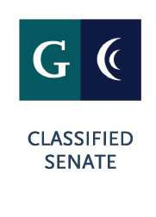

EXECUTIVE BOARD MEETING
Cuyamaca College

Wed. Nov. 28, 2018

2:30p – 4:00p
Location: I Bldg., Room 104
Attendees: Cuyamaca Executive Board
Guests: Bri Hays, Marvelyn Bucky

AGENDA

Meeting Called to Order: Meeting Adjourned:

# Agenda Item

CALL TO ORDER
  - Roll Call
  - Agenda additions/deletions/revisions to the agenda.
  - Approval of minutes from October Meeting

- ACTION ITEMS

- COMMUNICATIONS/DISCUSSION ITEMS:

  - Senate Updates-President
- SESC, IEC Charge/Composition Review
- Caring Campus Initiative and Logistics

  - Professional Development Updates

  - Committee Updates
- CCC Updates:
- Acceleration
- Guided Student Pathways
- Organizational Health
- Accreditation Presentation
- Vision for Success Alignment

  - Treasurer Report-if applicable.

Reference Materials: https://www.cuyamaca.edu/college-info/accreditation/accreditation-2019.aspx

Additional Instructions: Next Meeting-December meeting information TBD.

